**ALANYA ALAADDİN KEYKUBAT UNIVERSITY**

**RAFET KAYIŞ FACULTY OF ENGINEERING COMPUTER ENGINEERING DEPARTMENT**

**SEC 301.3**

**SOCIAL NETWORK AND SOCIAL NETWORK ANALYSIS**

**“****WHO IS THE MOST PROMINENT PLAYER AMONG THE PLAYERS OF THE TURKISH NATIONAL FOOTBALL TEAM WHO PLAYED IN THE LAST 5 WORLD CUP TOURNAMENTS?” Analysis Report**

**10.01.2024**

**Prepared by**

**Ramazan Bozkurt – Abdulkadir Sözgen**

**CONTENT**

**1.INTRODUCTION…………………………………………………...………2 1.1Project Title…………………………………………………………..2 1.2Project Objective…………………………………………………….2**

**2. TEAM ORGANIZATION……………………………………...…………..2**

**3. MATERIALS AND METHODS……………………...……...…………….3 3.1 Materials………………………………………………...…………...3**

**3.2 Methods……………………………..…………………….………….3**

**4. THE GRAPH…………………………………………………….…...….….4**

**4.1 Results………………………………………………………………..4**

**4.2 Discussion……………………………………………………………5**

**REFERENCES…………………………………………….……………….….7**

**1. INTRODUCTION**

In this section, brief information about the project title and project objective is included. The sections are listed below:

**1.1 Project Title**

The subject of our research is “Who is the most prominent player among the players of the Turkish National Football Team who played in the last 5 World Cup Tournaments” and the title for this research is “Most Prominent”.

**1.2 Project Objective**

Our research focuses on identifying the most prominent player among those who have played for the Turkish National Football Team in the last 5 World Cup Tournaments. The title of our research is ‘Most Prominent’.

**2. TEAM ORGANIZATION**

Our team comprises two members, Ramazan Bozkurt and Abdulkadir Sözgen. The table below outlines the team organization and task distribution.

|  |  |  |
| --- | --- | --- |
| **Job/Team Member** | **Ramazan Bozkurt** | **Abdulkadir Sözgen** |
| Data Collection | ✓ | ✓ |
| Transfer the data to the relevant program and creating the network | ✓ | ✓ |
| Analysis of the network and preparation of documentation | ✓ | ✓ |

**3. MATERIALS AND METHODS**

This section contains information about the method and material used in the research. The sections are listed below:

**3.1 Material**

[transfermarkt.com](https://www.transfermarkt.com.tr/) was used for collecting data then open-source network visualization and analysis software Gephi to analyse and visualize our networks.

We used Microsoft Excel to convert and format the data from the [transfermarkt.com](https://www.transfermarkt.com.tr/) to a data form that could be imported to Gephi for analysis.

**3.2 Method**

Handpick method was used in our research. Handpick method simply means the dataset used for this project collected by hand.

We created an undirected graph with the data collected from [transfermarkt.com](https://www.transfermarkt.com.tr/). Which can be seen below.

**4. THE GRAPH**

The Graph has 166 players who played in the last 5 World Cup for the Turkish National Football Team. Football players are the nodes, and playing together in a tournament creates an edge between them, making the graph undirected.

**4.1 RESULTS**

The Graph consists of 166 nodes and 5689 edges. In the Graph we see that our networks diameter is 3 and that its density is 0,415. There is only 1 component. We have an average clustering coefficient of 0.886. In this graph we have an average degree of 68,542 and an average weighted degree of 68,542.

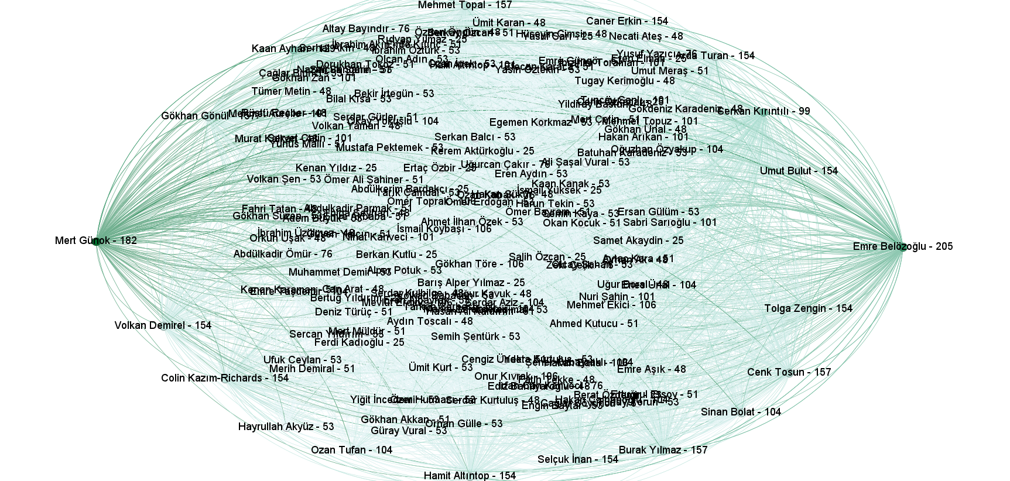

**4.2 DISCUSSION**

**Degree Centrality** gives us the node that knows the most actors. Emre Belözoğlu (205 connections) and Mert Günok (182 connections) have the most connections in the network. They are most prominent actors in the network.

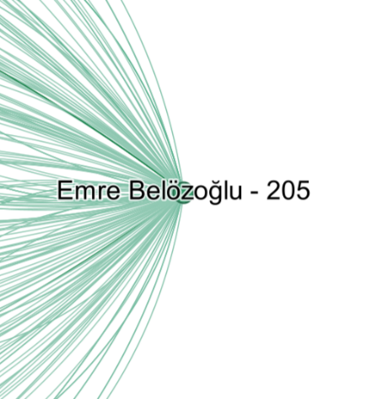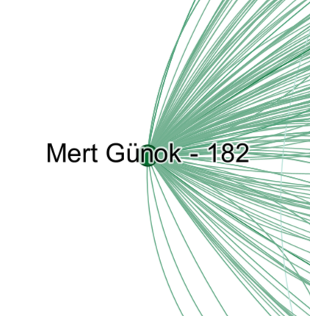

**Betweenness Centrality** is a measure of the centrality of a node in the network. It is often used to identify them as bridges. They play a key role in connecting different parts of the network. In this network, Emre Belözoğlu and especially Mert Günok are bridges. It means that they appear on the shortest paths between other nodes in the network.

The nodes that have the most connections in the social network are the most prominent figures. These are the nodes that played in the most tournaments with the most teammates. Mert Günok plays a key role in connecting different players on the network, however Emre Belözoğlu has the highest degree of 205. In addition, when it comes to connecting different players together there is no member as important as Mert Günok. Hence, Mert Günok plays a leading role in connecting different sets of players in different tournaments. This is clearly seen by the fact that Mert Günok has the highest betweenness centrality (1517,6583781632942) in the graph.

To sum up, Emre Belözoğlu and Mert Günok were in most of the last 5 World Cup Tournaments but Emre Belözoğlu did not play in the 2022 Cup and Mert Günok did not play in the 2006 Cup. Calculations show us that Emre Belözoğlu is the most prominent player of the Turkish National Team that played in the last 5 World Championships. Hence if we want to make a show game between the players of the Turkish National Teams that played in last 5 World Championships, the person we should call would be Emre Belözoğlu.

**REFERENCES**

[**https://www.transfermarkt.com.tr/**](https://www.transfermarkt.com.tr/)

[**https://www.geeksforgeeks.org/degree-centrality-centrality-measure/**](https://www.geeksforgeeks.org/degree-centrality-centrality-measure/)